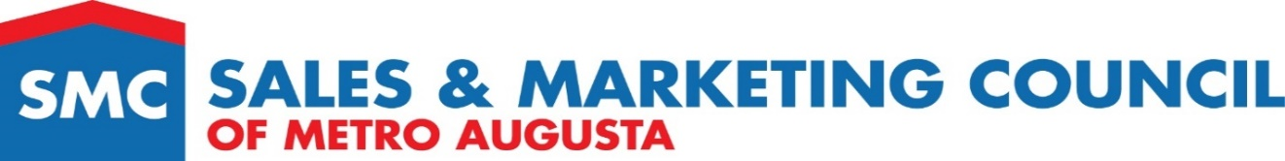

Form 9 - Best Special Sales Promotion/Single Event

Award Criteria

The best special event promotion, pre-sale event, grand opening, designed to promote a company, builder, community, or master planned development in 2023. One award will be presented to the community Sales Center with the best special sales promotion in 2023

.

Judging Criteria

Originality, concept, target marketing, overall design, and execution.

Applicant Information

Person Submitting _____________2023.____________________________________________________

Company ____________________________________________________________________________

Community Name ______________________________________________________________________

Community Location _____________________________________________________________

Information Needed Check List
________ | Marketing statement and brief explanation of why you think this campaign should receive this award
________ | Digital photo of each ad, invitation, press release and other materials produced for event
________ | Professional color photos of event
________ | Community logo
________ | Picture of company and/or person(s) that created this promotion

Submitted by (signature)

Contact number ________________________________________________________________________

Broker/Manager Approval (print & sign) _____________________________________________________

